Addis Ababa University

Data Science and Cloud Computing in Bioinformatics
Assignment I
Analyzing Published Biological Dataset Using the Data Science Workflow

Name: Beyene Chalchisa
ID N_{O}: GSR/4596/18

Augest, 2026

Published research Titles: “Profiling maize embryonic leaf development and discovering new genes using high-resolution spatial long-read isoform sequencing
Dataset/study: Maize embryonic leaf spatial transcriptome
Organism: Zea mays (maize)
Sources: Nature Plants (2026) sites
Web.: https://www.nature.com/articles/s41477-026-02364-y
1. Research questions (pages 1-2)
The primary research questions posed by the published article are:
- What transcript isoforms and genes are expressed in maize embryo leaves?
- What are the spatial expressions of these isoforms?
- Is it possible to distinguish development stages using isoform-level expression that cannot be distinguished using the gene level?
- What are the genes and regulatory pathways involved in embryonic vein formation?
2. Data source (page 1 -3)
The experiment collected the primary data which involved the use of maize embryonic shoot/leaf tissue. However, from the primary data collected, 285,639 isoform transcripts were collected from which 72.87% had not been characterized before.
The scientists did this by:
- Collecting maize embryos shoots.
- Sectioning the samples horizontally in four serial sections.
- Binding the sections to 10x Genomics Visium Gene Expression.
- Capturing the transcripts by use of spatial barcoding and UMIs.
- Generating full-length cDNA.
- Sequencing full-length molecules through PacBio HiFi sequencing.The study also incorporated
secondary data /public datasets, including:
- 30 published LCM RNA-seq datasets for maize embryonic leaf cells.
- Public ATAC-seq data from six maize tissues, retrieved from NCBI SRA under PRJNA1048297.
- Additional bulk RNA-seq datasets representing different maize developmental time points.

3. Data type (2-4)
The researches contain a multi-omics biological dataset, with several data types including:
- Long-read RNA sequencing
- Spatial transcriptomics
- Short-read RNA-seq
- ATAC-seq
- Histology images
- Gene annotations
- Isoform annotations
4. Data collection method (page 4)
The biological data-collection workflow was approximately:
Maize embryonic shoot tissue sectioning Visium slide spatial RNA capture barcoded cDNA MAS library PacBio sequencing HiFi reads isoform identification spatial isoform expression
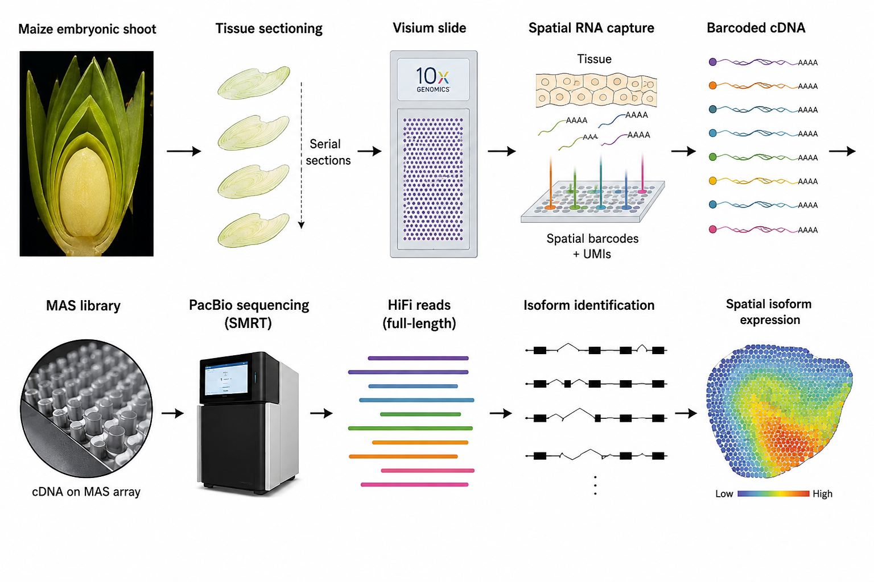
5. Data cleaning steps (page 2)
The study involved several computational cleaning and quality-control steps.
A. Long-read RNA-seq
The reads were:
- Collapsed into transcript isoforms.
- Mapped to the Z. mays B73 RefGen_v5 genome.
- Reads that did not map to the reference genome were excluded. Of approximately 38.89 million reads, 344,945 (0.89%) did not align and were excluded; 38,543,204 reads were uniquely mapped.

B. Gene-model filtering
Potential novel genes were filtered using multiple criteria, including:
- Protein homology
- Expression support
- Protein-domain prediction
- Independent annotation
This reduced an initial pool of 6,878 putative novel genes to 5,228 validated novel genes.
C. ATAC-seq cleaning
For the secondary/public ATAC-seq data:
- Adapter sequences were trimmed out.
- Low quality bases were trimmed out.
- Reads were aligned to B73 RefGen_v5.
- PCR duplicates were eliminated.
- Mitochondria were excluded.
- Only uniquely mapped reads were selected.
- Peaks for chromatin accessibility were identified.
6. Exploratory analysis (page 5-9)
The researchers performed several exploratory analyses before interpreting biological functions.
6.1, UMAP
UMAP was used to examine overall expression patterns and spatial spots. The gene-level, long-read gene-level and isoform-level datasets showed similar overall tissue organization.
6.2, Clustering
Unsupervised clustering identified:
- 7 clusters at gene level
- 6 clusters at isoform level

The clusters corresponded to tissue/developmental domains such as:
- SAM_P1
- P2_P3
- P4_P5
- shoot_col
- embry_v1
- embry_v2
- Importantly, the gene-level embryonic vein cluster was separated into two distinct isoform-level clusters, embry_v1 and embry_v2.
6.3, Reproducibility
- Used person’s correlation:
r = 0.958, P < 2.2 × 10⁻¹⁶.
7. Analysis or modeling method (page 5-11)
- Several data-science and bioinformatics methods were used.
Method used | Purpose
PacBio Iso-Seq/MAS-IsoSeq | Identify full-length transcript isoforms
Genome alignment | Map transcripts to maize genome
GffCompare | Compare novel isoforms with reference gene models
UMAP | Reduce dimensionality and visualize expression patterns
Unsupervised clustering | Identify tissue/developmental domains
Differential marker analysis | Identify cluster-specific isoforms
WGCNA | Identify isoform co-expression modules
GO enrichment | Determine biological functions
Monocle 3 | Reconstruct developmental trajectories
CytoTRACE | Estimate differentiation states
ATAC-seq analysis | Examine chromatin accessibility
Protein-domain analysis | Assess potential function of novel isoforms
AlphaFold3 | Predict protein structures/stability
Pseudotime analysis | Model developmental progression
Unsupervised clustering | Identify tissue/developmental domains

8. Visualization approach(page 4-12)
Some biological data visualizations used in the experiment include:
- UMAP plots - Spatial transcriptomic cluster visualizations
- Spatial tissue maps - Indicate where there is expression in maize tissue.
- Violin plots – Used to compare gene/isoform expression
- Sankey plots – Comparison of gene-level and isoform-level clusters
- Heatmaps/bubble plots – Patterns of module and functional enrichments.
- Co-expression network graphs – Relationship between isoforms.
- Pseudotime trajectories – Developmental trajectory.
- Genome browser/IGV plots – Visualization of novel exons and transcripts.
- Histological images – Validation of spatial tissue domains.
Example: Figure 2 – Figure 6 represents the Visualization approach.
9. Biological interpretation (page 5 -11)
The Researcher provides several important biological findings ( analysis).
A. Many maize isoforms were previously unknown
The study identified:
- 285,639 isoforms
- 72.87% previously uncharacterized
- 5,228 novel genes
- 1,674 genes with extended 5′/3′ regions
B. Isoform-level analysis provided greater resolution
- At gene level, the embryonic vein appeared as one cluster. At isoform level, it separated into embry_v1 and embry_v2, suggesting different developmental stages of vein formation.

C. Auxin signaling used
The embry_v1 cluster contained isoforms associated with:
- Auxin efflux
- Auxin-activated signaling
- WAT1-RELATED
- ATL1
- IAA25
D. ZFP30 is associated with vein development
- Several ZFP30 isoforms showed specific expression in embryonic vein domains.

E. Development follows divergent trajectories
- Pseudotime analysis suggested two major developmental paths:
1, SAM_P1 → P2_P3 → P4_P5 → shoot_col and
2, SAM_P1 → P2_P3 → embry_v1 → embry_v2
10. Limitations and challenges (pages 7, 9 and 11)
Several limitations can be identified from the paper.
1. Limited number of spatial spots in embryonic vein tissues
- The authors specifically noted that they could not identify co-expression modules exclusively specific to embryonic vein clusters, probably because there were relatively few spatial spots in these tissues.
2. Novel isoforms have lower reproducibility
- Although the overall replicate correlation was high, reproducibility varied by isoform category. Full-splice-match isoforms had 78.65% overlap, whereas NNC isoforms had only 28.28% overlap.
3. Complex gene-model annotation
- Novel isoforms can overlap existing genes, producing ambiguous read assignment and potentially affecting gene-expression quantification.
4. Computational complexity
- The workflow combines spatial transcriptomics, long-read sequencing, genome annotation, clustering, WGCNA, pseudotime, ATAC-seq and protein analysis. This makes the analysis computationally and technically demanding.
5. Novel isoforms require validation
- Computational identification alone does not establish biological function. The researchers therefore used multiple lines of evidence, including coding potential, protein domains, poly-A motifs, ATAC-seq and experimental in validation.
Summary of this written research’s Workflow’s

